**EXPERIMENT 2**

**Aim :**

Build a Computer-to-Computer, Peer-to-Peer, Network (Ad-Hoc Wi-Fi Network).

**Theory :**

Ad-Hoc mode refers to a wireless network structure where devices can communicate directly with each other. It is an additional feature that is specified in the 802.11 set of standards, which is referred to as an Independent Basic Service Set (IBSS).

This type of wireless network is also called peer-to-peer mode. An ad-hoc wireless network is more cost-effective than its alternative, since it does not require the installation of an access point to operate. In addition, it also needs less time to set up. An ad-hoc mode is often used in urgent situations when fast and efficient communication is needed, such as search-and-rescue operations. This type of network is also used in small groups, where the main purpose of the connection is file-sharing.

On the downside, ad-hoc wireless networks may slow down network performance and are harder to manage. Since there is no centralization, there is practically no distribution system present. Network performance in this mode decreases as the number of devices increases. Because of this limitation, ad-hoc mode is not ideal to use for numerous devices and large work groups.

Setting up an ad-hoc network is useful if there isn't a wireless structure built, like if there aren't any access points or routers within range. The devices don't need a central server for file shares, printers, etc. Instead, they can access each other's resources directly through a simple point-to-point wireless connection.

**How to Set-Up an Ad-Hoc Network?**

***Requirements –*** The devices that are going to take part in the ad-hoc network have to have a wireless network adapter installed. They also have to support a hosted network.

***Testing –*** To see if your wireless adapter has hosted network support, look for it in Command Prompt after running the netsh wlan and netsh wlan show drivers command. You might need to open Command Prompt as an administrator for that command to work.

**Screenshots : Testing**

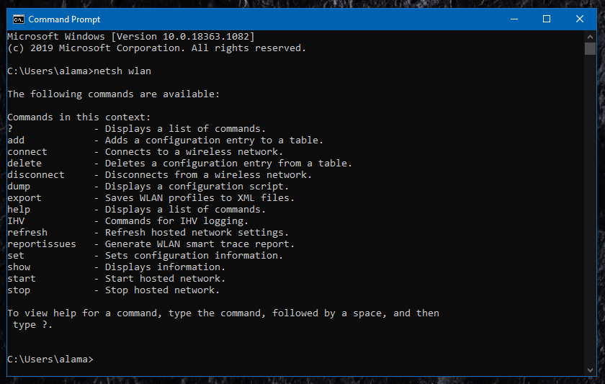

netsh wlan *command*

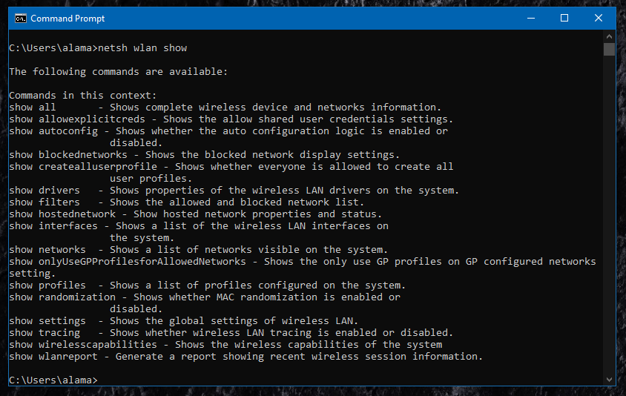

netsh wlan show *command*

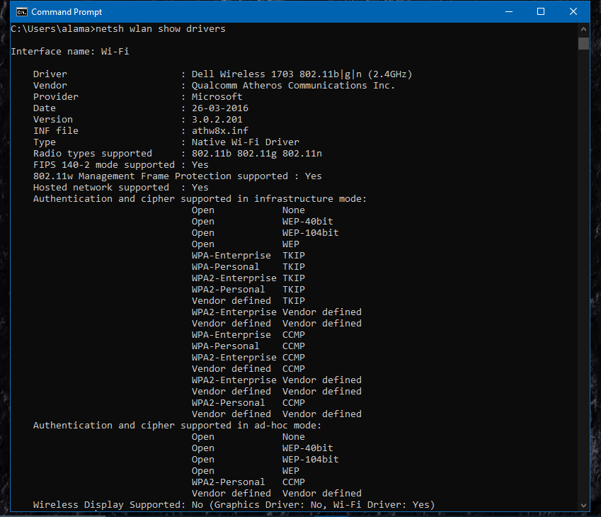

netsh wlan show drivers *command*

**Setting-Up Ad-Hoc Network in Windows 10 :**

1. Open Command Prompt and run this command, replacing the italicized words with your own network name and password for the wireless network :

netsh wlan set hostednetwork mode=allow ssid=*network name* key=*password*

1. Start the hosted network :

netsh wlan start hostednetwork

1. Open Control Panel, navigate to \Network and Internet\Network and Sharing Center. All the active networks will be available here.

**Steps :**

**1.** Open Command Prompt using “Run as Administrator” option.

**2.** Enter the following command and press “Enter” :

netsh wlan set hostednetwork mode=allow ssid=*adhocnetwork* key=*eatapple*

Here, network name is *adhocnetwork* and password is *eatapple.*

**3.** The hosted network mode has been set to allow. Now enter the following command and press “Enter” to start the hosted network :

netsh wlan start hostednetwork

The hosted network has started, close the Command Prompt.

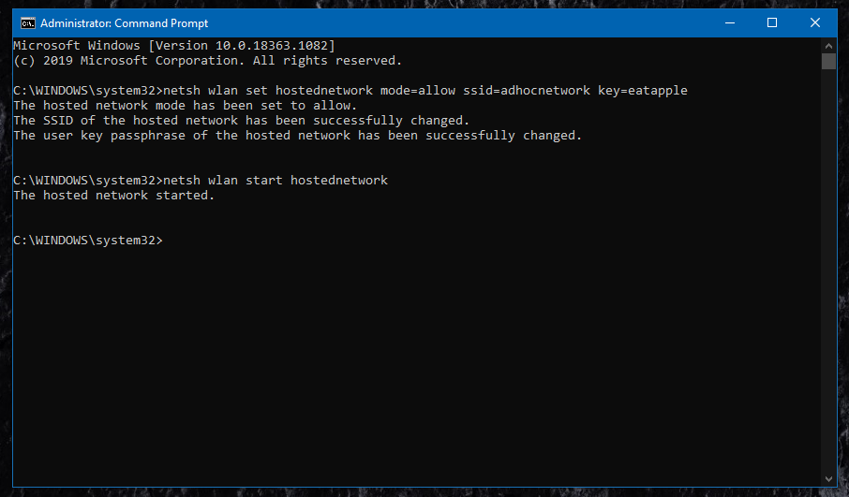

**4.** Open Control Panel, navigate to \Network and Internet\Network and Sharing Center. All the active networks will be available here.

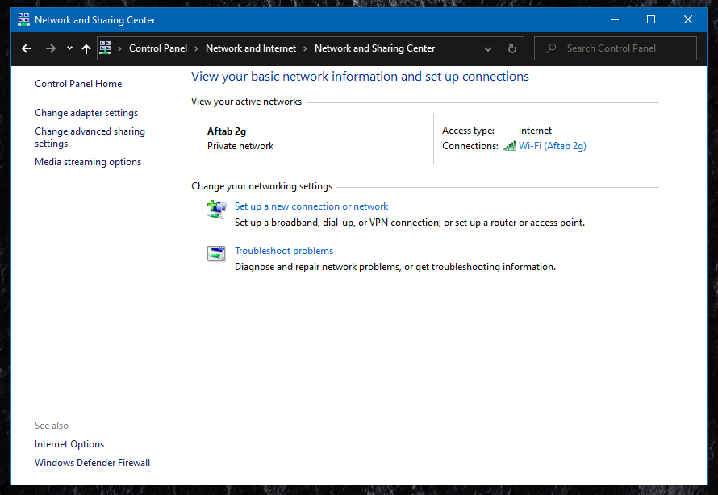

*Network and Sharing Center* ***before*** *setting-up ad-hoc network*

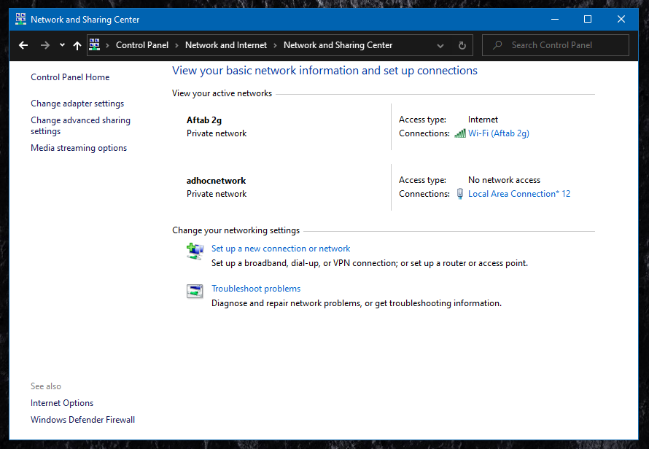

*Network and Sharing Center* ***after*** *setting-up ad-hoc network*

**5.** Enter the following command in the Command Prompt and press “Enter” to stop the network :

netsh wlan stop hostednetwork

The hosted network has stopped, close the Command Prompt.

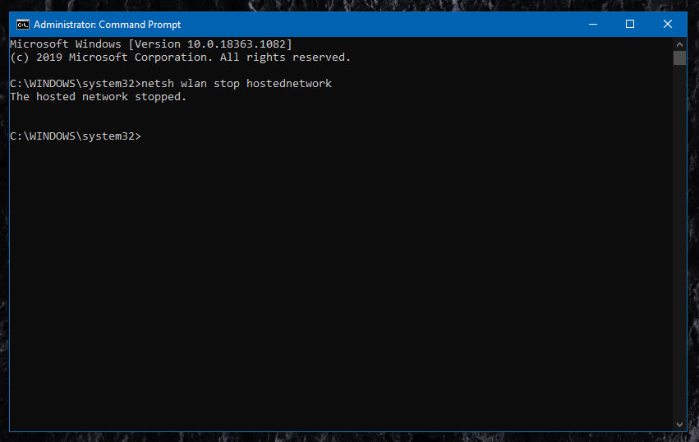

**6.** Open Control Panel, navigate to \Network and Internet\Network and Sharing Center. Only your Internet Network will be available in the active networks. Your ad-hoc network set-up is complete and you can always turn it on by the above mentioned steps.

